Example Corp of Tampa, Florida

Voicemail development proposal

Beam group  
www.teambeam.bizz  
123-456-7949  
proposals@teambeam.bizz

2021

# **Cover Letter**

Betty Boop  
Example Corp. of Tampa Florida  
123 Main Street  
Anytown, USA 12345

Greetings, Example Corp. of Tampa, Florida.

We are reaching out to you today, on behalf of Team BEAM. Our team noticed your company’s desire to expand with the addition of a new voicemail system. We look to offer you a solution with a hosted service or we can work to build you a local system. Based on our experience with building similar systems successfully in the past for our clients, our recommendation would be to build a VoIP system with our hosting as then the system will be highly scalable as the number of employees and the usage of VoIP within your company grows.

We will work with absolute dedication to provide a phone voicemail system that best matches your needs. When you work with Team BEAM you will have the best experience as you have ever seen!

To better serve our clients, we recently added hosting to our services and have some of the most competitive pricing on the market. We would love to take some time and discuss our successes in VoIP space, track record, development methodology and project specific details.

You may reach out to us at your earliest convenience.

We look forward to hearing from you,

Sincerely,

Alex Crawford & Ashwin Srivastava  
BEAM Group

**PROPOSAL**

# Requirements (Software)

Per your business’s requirements, you requested the following features:

* Friendly, easy to use voicemail system that all can use.
* Play back messages
* Delete messages
* Change the greeting (per mailbox)
* Change the password (per mailbox)
* Administrator ability to activate and deactivate mailboxes
* Administrator ability to copy/play messages (from any mailbox)
* Store messages so they can be retrieved in the event of a power outage.
* Ability to back-up the stored data and restore it.

# Timeline

* Proposal due by March 15th, 7:00 pm EST.
* Phase 1 must be completed and delivered by February 1 of the following year.
* Phase 2 Engagement work complete and voice mail system live – TBD
* Phase 3 – Administrative options and backup capability - TBD

# Proposed Solution

Beam group works very closely with their customers to understand the requirements and build highly performant, scalable and resilient solutions. Our initial planning phase will involve walk through of requirements by the representatives of your company and we will also capture the detailed requirements. We have a lot of experience in building systems and have a strong track record for delivering the project on time and within cost. Our last 15 projects with revenues > $20000, have been completed a month early, and have required less than 2 hours of technical support (0 emergency situations). The primary benefit of working with BEAM Group is the expertise of our very accomplished team which helps us in building high quality systems for our clients.

# Budget & Fees

## Phase 1 Budget: $10,000

Milestones to be complete during this phase:

* Project analysis
* Developer requirements
* Site definition
* Architecture design
* Create and Structure Database
* Identification and implementation of any additional software requirements
* Import existing data (employees, titles, permissions)

## Phase 2 Budget: $15,000

Milestones to be complete during this phase:

* Create a user interface with client input
* Create and implement storage of voicemails.
* Create and implement playback of voicemails.
* Create and implement deletion of voicemails.
* Create and implement user authentication.
* Create and implement user levels (Users, Administrators, HR)
* Add feature to update greeting and change password.
* Automatic storage of voicemails on local server.
* Automatic configuration and restore of voicemails during application startup.

## Phase 3 Budget: $7,000

Milestones to be complete during this phase:

* Add feature to allow (user level) Administrators and HR to access any mailbox.
* Add feature to allow (user level) Administrators copying of voicemails.
* Add feature to allow (user level) Administrators to activate/deactivate mailboxes.
* Add feature to allow for backup and restore ability.

## Phase 4 Budget: $3,000 (optional)

Milestones to be complete during this phase:

* Implement cloud storage with user access. (Voicemails can be retrieved from any device, anywhere)

# Qualifications

## Our firm has produced three similar systems successfully in the VoIP space.

We co-created a system that allowed for voicemails to automatically bind to the Customer’s file in a cloud base CRM system. We worked with the developers of the CRM system to implement the voicemail storage feature. We have created a system for a large Corporation that wanted the ability to call and put in a helpdesk ticket. We created a feature that allowed us to store and upload the file as a new helpdesk ticket that provided the call back number to the IT team. Lastly, while not completely relevant, we have released version 1.0 of our new ERP software, “**AIManagement**”. It is a cloud based ERP system that allows for users to work from anywhere in the world, on any platform.

# References

Pollock Corporation Inc.  
952 Piffl Ln  
Tampa, Fl 33212  
Phone: 1-212-323-2313  
E-mail: [hpiffle@pollockcorp.com](mailto:hpiffle@pollockcorp.com) (IT Director)

Fishing Spears LLC  
423 Cameron Blvd  
Tampa, Fl 33442  
Phone: 1-322-353-231  
E-mail: [cspears@fspearsllc.com](mailto:cspears@fspearsllc.com) (Owner)  
  
Brick Implements Throwable LLC  
130 Byte Overflow St   
Tampa, Fl 32142   
Phone: 412-101-2311  
E-mail: [char.broiled@bitllc.com](mailto:char.broiled@bitllc.com)

# Organization Capacity

We currently employ 5 developers and 1 technical support staff. All of our staff have a company laptop and desktop. Laptops are primarily used for working remotely or visiting a customers physical location. Each employee also has three monitors attached to their workstation. All items requiring power are hooked to a 45-min UPS (each station). We use Idea Intellij IDE as our primary software to code, Visio for mapping out projects, outlook for customer communication, and slack for communication amongst the employees (day to day). We are in a 10,000sq/ft office space with cubicles and hot coffee!. Currently only 6 cubicles are being used of the 12 available. Our office location can be found on the cover sheet. With regards to capacity and ability to produce the voicemail system, we are a small company, so it is all hands on deck. We have completed many successful projects together. Our strength is in our collaboration and diverse background. We incentivize our team with 10% profit sharing (broken up into 2 parts). Part one, meeting delivery date yields 3% of the profit sharing. Part two, zero major software issues after 6 months.

Organization Chart

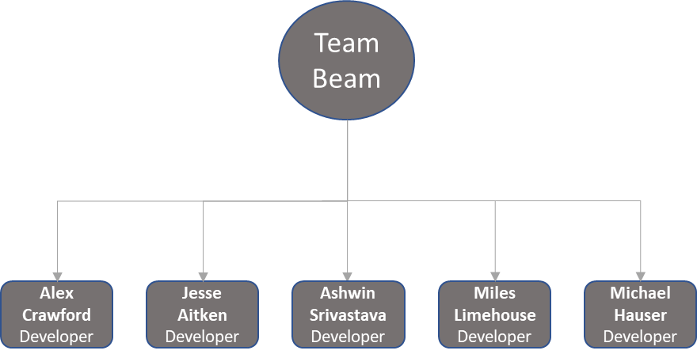

# Company Profile

BEAM Group is a small software development company that specializes in file storage, cloud storage, and software innovation. BEAM Group has been in business for six years. The primary programming language is Java, although other languages are used as needed. Our mission is to create software solutions that satisfy our customers needs at every level of the business. Our vision is to be a world class software development company that create innovative solutions for big and small businesses.

# Role Assignments

Jesse Aitken – Software architect   
Jesse has been a developer for 14 years and has held roles in many large Corporations such as Microsoft and Amazon as a lead in Cloud Software Architecture.

## Alex Crawford – Senior Lead Software Developer

Alex has been a developer for 17 years and has held roles at Bank of America as a Senior Software Developer, and General Dynamics as a Senior Developer at CENTCOM (Top secret clearance required)

## Ashwin Srivastava - Senior Lead Software Developer

Ashwin has been a developer for 15 years and has held roles at Google and Facebook as a Software Developer.

Miles Limehouse – Software Developer

Miles has been a developer for 8 years and has held roles at Walmart as a Software Developer.

MichaelHauser - Software Developer

Michael has been a developer for 9 years and has held roles at Citi Group and Facebook as a Software Developer.

# Project Planning Process

We follow a simple project management process that has served us well. It is broken up into six phases with specific steps/questions to answer in each phase. The six phases are Planning, Analysis, Design, Implementation, Testing & Integration, and Maintenance.

# Total revenue from voicemail/PBX developments

While we do appreciate the opportunity to submit a proposal for this project, we do not share earnings from past projects. We believe this is irrelevant, as each customer has their own specific criteria. The more criteria, the more a project will cost. We bid on projects low enough to win bids over other companies. While we have provided you with three references to existing/past customers, we can give you a more holistic list that shows how many repeat customers we have (multiple projects done for same customer).

# Business Model

BEAM Group operates under a transaction-based business model. We have considered moving to a subscription model, but we are trying to build capital and talent prior to this transition support moving to this model.

# IPOs, Mergers, and Acquisitions:

We do not plan to become a publicly traded company. At this time, there are no merges or acquisitions in process. Nor is there any active discussion around a merger or acquisition.

# Hardware/Software Partnerships

N/A

# Testing/Support Plan

All software produced by BEAM Group goes through agile testing, unit testing, integration testing, and full system testing. For this system, we have agreed to provide 20 hours of tech support per year, for two years. The clock starts once we have agreed on the successful deployment. If this does not suffice, we can discuss additional support hours and charges. However, based on our previous experience, we think that 20 hours of tech support per year, for two years should well address your needs.

# Service Level Agreement

BEAM Group agrees to the following levels of service, based on severity of the situation.

|  |  |  |
| --- | --- | --- |
| **Severity Level** | **Severity Definition** | **Response Times** |
| 1 | System is down and will not restart using documented procedures. Operations impacted. | Within 15 minutes. |
| 2 | Operations continued, but system needs to be fixed ASAP. Cannot access voicemail system. | 4 Hours |
| 3 | Intermittent problems, hard to reproduce. Affecting operations, but not all. | 2 Days |
| 4 | Informational only. | 3 Days |

# Estimated Time for Completion

BEAM Group commits to having Phases 1-3 complete by July of the following year. We will contractually agree to reduce the total price by $500/week there after as a penalty, up to $5000.

# Terms and Conditions

BEAM Group’s completion date is based on the assumption of completing three phases. If Phase 3 is not added as part of the contract or if Phase 4 is added to the contract, the timeline will change. BEAM Group will renegotiate the completion date and potential penalties in that situation. Staffing is subject to change as BEAM Group sees fit. We will only hire developers equivalent or greater than our current staff. Prices of each phase are subject to change if requirements of the project change. Price may increase significantly if features are requested beyond phase 1.